Community Resilience Network
Workshops 1&2 20 September 2024 at the Papakura Local Board Office
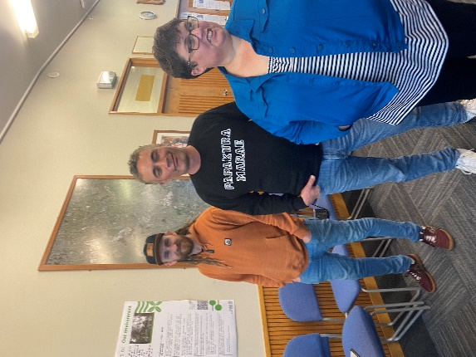
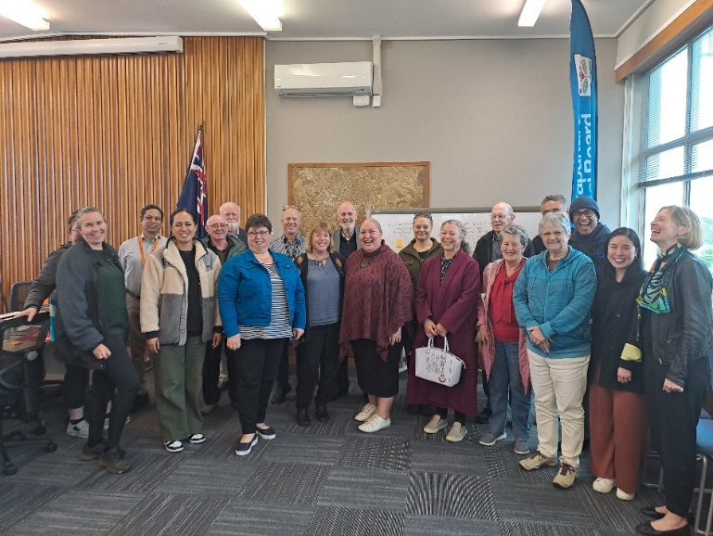

Changes you are seeing in Papakura
Sea level rising | Some polar blasts but short | Difference in neighbourhoods | Pressure on existing water infrastructure
Pahurehure Estuary - level rising | "Wet more frequent and higher intensity | Housing increase  More housing | Council response?
Water closer to cliffs and path | Increased water makes thing grow more | 70k+ PEOPLE INCREASE OF 56% in the last decade | ESOL (English to Speakers of Other Languages)
Erosion | 18 months of constant downpour. Mental impact GIVoNZ Study | Changing demographics | Reduced social connection  Need to develop social connection
Water - no space  Water- design ways to allow it to get to where it needs to go | Some have seen an increase in established gardens and bush | Smaller or no garden space impact" | Used to be town and country now urban  Food growing as no space @home
The climate is haywire  Weather becoming more unstable mixed up intensity increase | Loss of native bush tress -big trees  "Margins bush  birdlife not as plentiful” | Microclimates becoming obvious, less predictable | Physics CO2 less than historically been e.g. GLA
Warmer hotter for longer  Overall Weather - 40-year 23-24 degree C  Now 27-28 degree C + | Loss of bird food sources" | Reducing trees  Urbanisation of larger areas with not trees  Are trees planted? | Manuroa Road development and infill housing

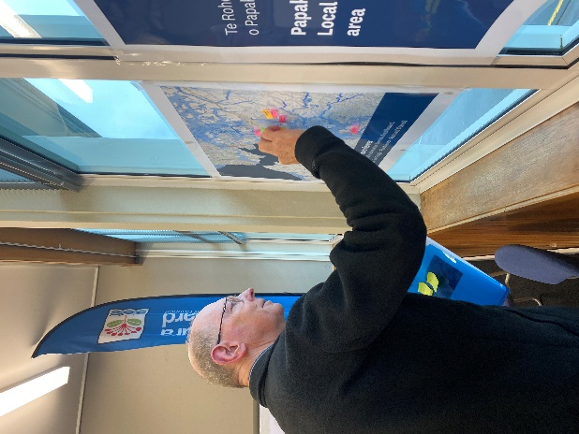
Ideas for things you could do
- Feed a community
- Plant pots with leader leaves of spinach and pop them in letter boxes
- Can we use land banked land for agriculture?
- Rates
- Unitary Plan should support farming/growing
- Encourage people to grow food and stay agricultural

Things you said
My bird bath froze over two times last year in spring. It was very odd. Things are happening with the weather at unexpected times.

I don’t understand Māori language so understand how all people need to have translations to understand what is going on.
We have noticed that our plants are flowering earlier than expected and it is different each year
It is nice to know there are real people at Auckland Council that want to help.
We are limited by our premises, and it would be perfect as it would have enough room for us to host other groups working on sustainable climate action projects.

