Disability Community at Papakura Marae

Workshop Wednesday 30 October 2024
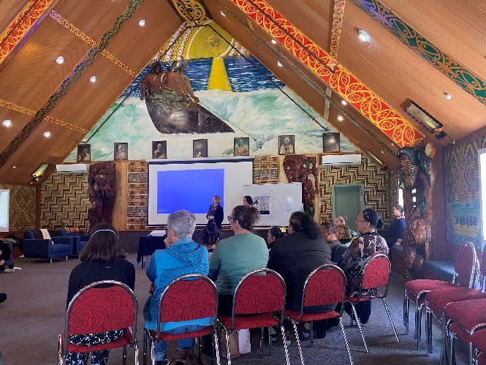
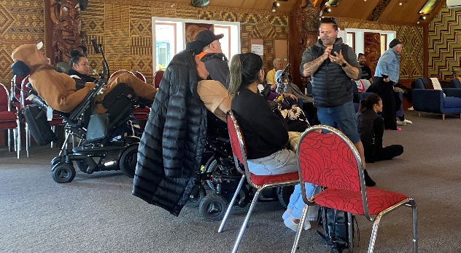
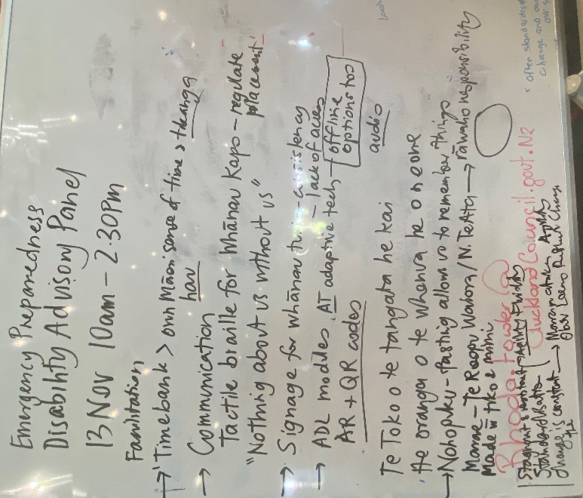
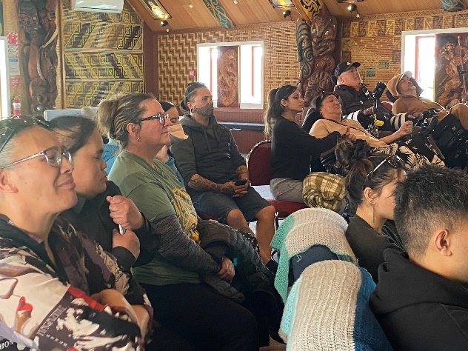
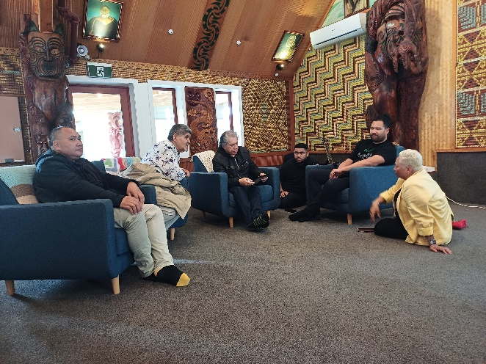

What you talked about

We need online techniques so people with different abilities can access information fairly. We need braille, talking websites etc.
We can runaround planting and doing lots of wonderful work with Auckland Council’s support, but developers are still being granted consent from another part of the council to chop down mature trees on private land, with no requirement to replant either.
Non-permeable surfaces create fast tracks for water and flooding too - nowhere for water to go except straight out to sea. Make it make sense!
Indigenous People would agree, climate change is not something to fight. We don't fight the Taiao, we are part of it.
Why are we talking about a Papakura dollar when Maori have been doing this as part of our lives. It is our way to look after our whanau, hapu, iwi.
What would be beneficial would be a sign version of Flood viewer so we can understand. We need to have access.
It is time to look at dealing with the long-standing issues for you fullers then we can nail it for everyone.
We want to mihi all the work that has been done in this space energy, cost of living, kainga.
Our food system is broken. I will be honest about that. We need to grow our own kai where we live, and we need to share.
We need to be more connected to community supported agriculture. If the farmer knows more about how many need to be grown and harvested, there is less waste.
There is lots of knowledge we can delve into.

Ideas for things we could do

Summary
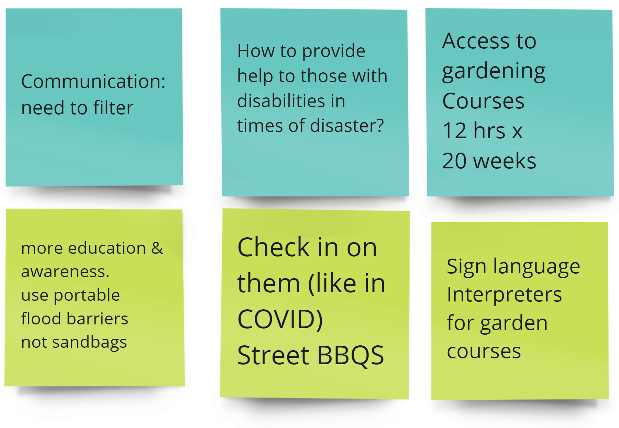

Full list

Idea | Idea 2 | Idea for how | How
Noho puku >Tiko  >Recycle> (this is a cycle diagram) | Stop rubbish being flushed to sea if there is flooding
Te toto o te tangata he kai he organs ot te whenua he oneone.  (this is the centre of the cycle) | Require new buildings to have solar and rain tanks so runoff water can be used
Translates to: With m Baske and Your Basket the community will thrive | Solar and rain tans and retro fit scheme for old homes
 | Deaf community Auckland QR
 | Provide infrastructure for growth
 | Time bank Tikaanga
 | Solare power Tikaanga
 | Water > mangrove swamps |  | Moana i te Repo
 | Access to gardening courses e.g. 12hoursx20 weeks |  | Sign language interpretation for gardening courses
 | How to provide need to those in need in times of disaster due to disabilities | Check in on them (like in COVID) Street BBQs
 | Communication needs to filter |  | More education??? And? citizen or awareness  use portable flood barriers not sand bags
Having information in Braile for kāpo? | How is risk communicated i.e. Flood map not accessible at all | Easy read  Interpreters  Ability to adjust brightness  te reo and … ?easts? | Use Paerangi website as an example  Home | Paerangi
 | Trams that are self-operating will be an issue whanau kāpo | Public transport advocates  Equal access subsidies
 | Bike and scooter lanes Concerning for whanau hauā? | Scooters off the footpath bylaws/fines
 | Having more accessible parks for tamariki and parents? | Local Board to update playgrounds
Mara kai
Recycle
 | Green roof | Activations  Reuse tech in new ways
 | Weather conditions - worm farm | Learn animal behaviour | Maramataka
 | Playgrounds  Park access for Kapo  Traffic lights  Footpath, Field | More access to Braile/tactile information e.g. maps to be aware of champs
 | Solar Panel
 | Gorilla planting` | Control industrial waste  make business pay for their waste | Have inspectors hold them to account.

