Drury Community
Workshop Saturday 12 October 2024
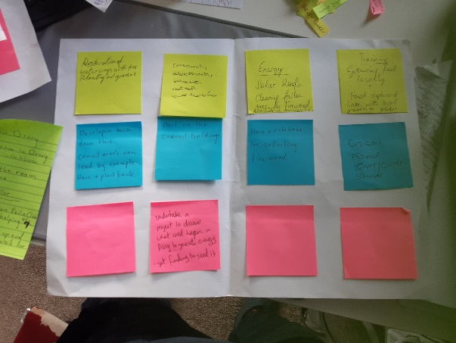
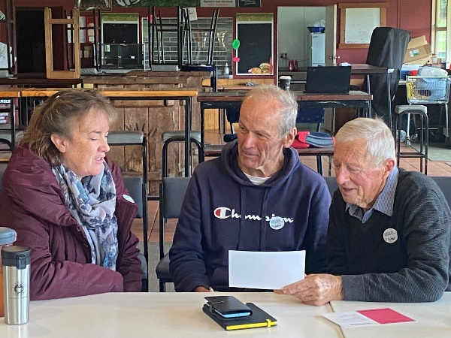
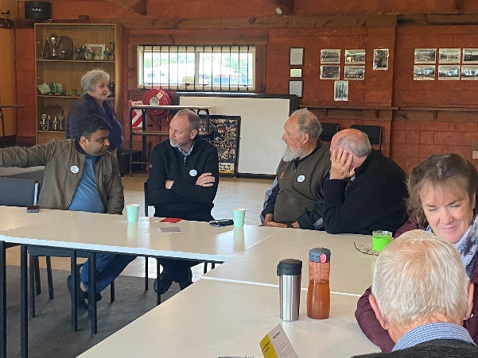

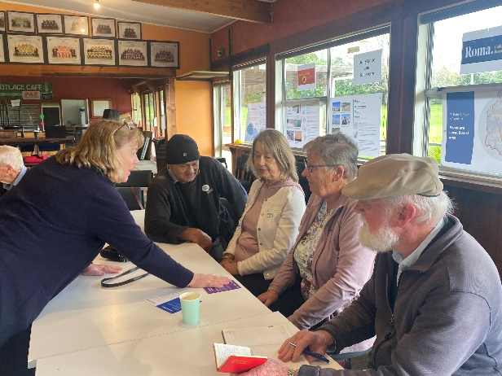

What you talked about
The community does not know what is happening around the Drury structure plan and that is vital for us to be able to make plans
It is people like you who can speak up because it is people like us who can’t speak.
My house was struck by lightning a couple of weeks ago. I am currently in the rebuilding process
Communities need to get better at interacting and getting to know each other even in good times.
To do community work on our property we asked for rates relief from the council, they said we needed to get community funding.

The post it notes you created

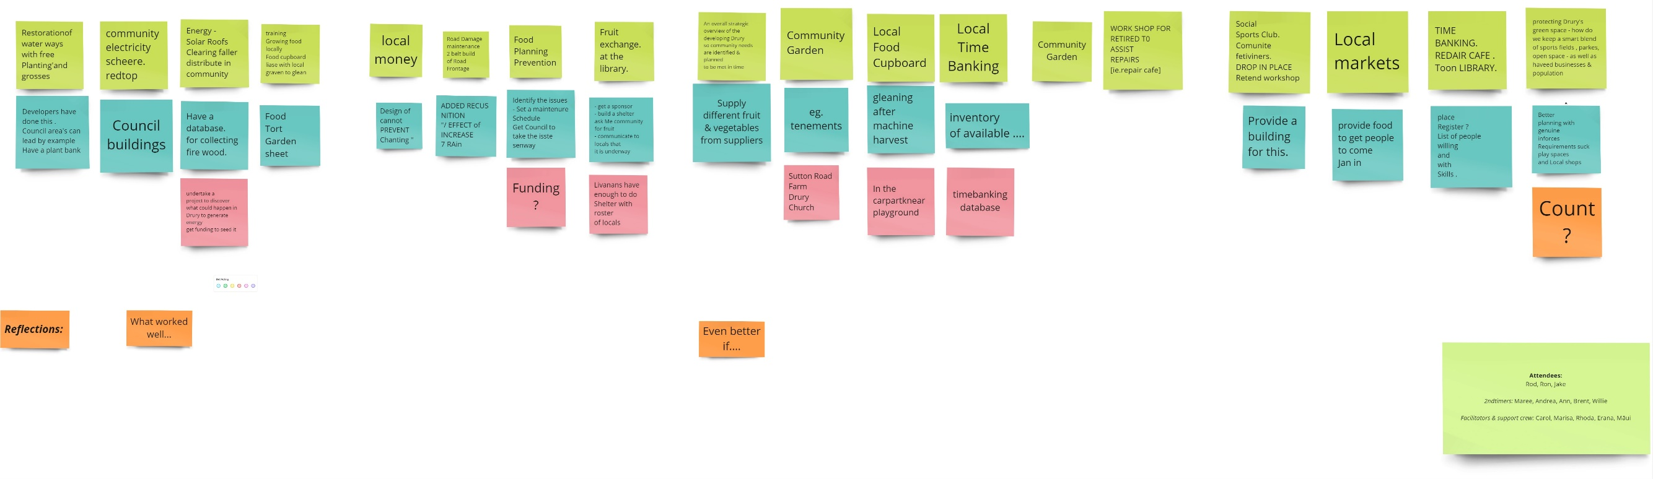

Ideas for things we could do

What can we do? | Idea for how | Idea for how
Local markets
Promote buying locally
More community events to help bring people together to improve local networks
An overall strategic overview of the developing Drury So community needs are identified and planned to be met in time.
Community Social meeting  Sports Clubs  Community Activities  Drop in Place  Retired workshops | Proivde a building for free
Workshop for retied to assist repairs | Proivde food to get people to come and join in
Time banking  Repair Café  Tool library | Place  Register  List of people willing and will skills
Protecting Drury's green space - how do we keep a smart blend of sports fields, parks, open spaces as well as houses, businesses and population | Better town planning with genuine enforced requirements such as play spaces and local shops | Council
Community Garden | Supply different fruit and vegetable from supplies
Community Garden | Allotments An allotment is a plot of land made available for individual, non-commercial gardening for growing food plants, so forming a kitchen garden away from the residence of the user.
Local food cupboards
Local time banking
Community garden | create a register of available land | Sutton road farm Drury church
Local money` | Design of control to prevent cheating
Using land for purpose take precedent over future planning by Council for e.g. farms
NO rates on community gardens
Road Damage | Crack maintenance and silt build up  maintenance of Road frontages | Added recognition of effect of increase of rain
Flood planning prevention | More community awareness and communications  Identify the issues  make a maintenance schedule get Council to take the issue seriously | Funding
Fruit exchange at the library | Get a sponsor  Build a shelter  Ask the community for fruit  communicate to locals that it is underway | Libraries have enough to do  Shelter with roster of locals
Restoration of waterways with tree planning and grasses | Developers have done this. Council areas can lead by example | Have a plant bank
Community electricity scheme Roof top or wind turbine | Start on the council building | undertake a project to discuss what could happen in Drury to generate it  - Get funding to see it.

