
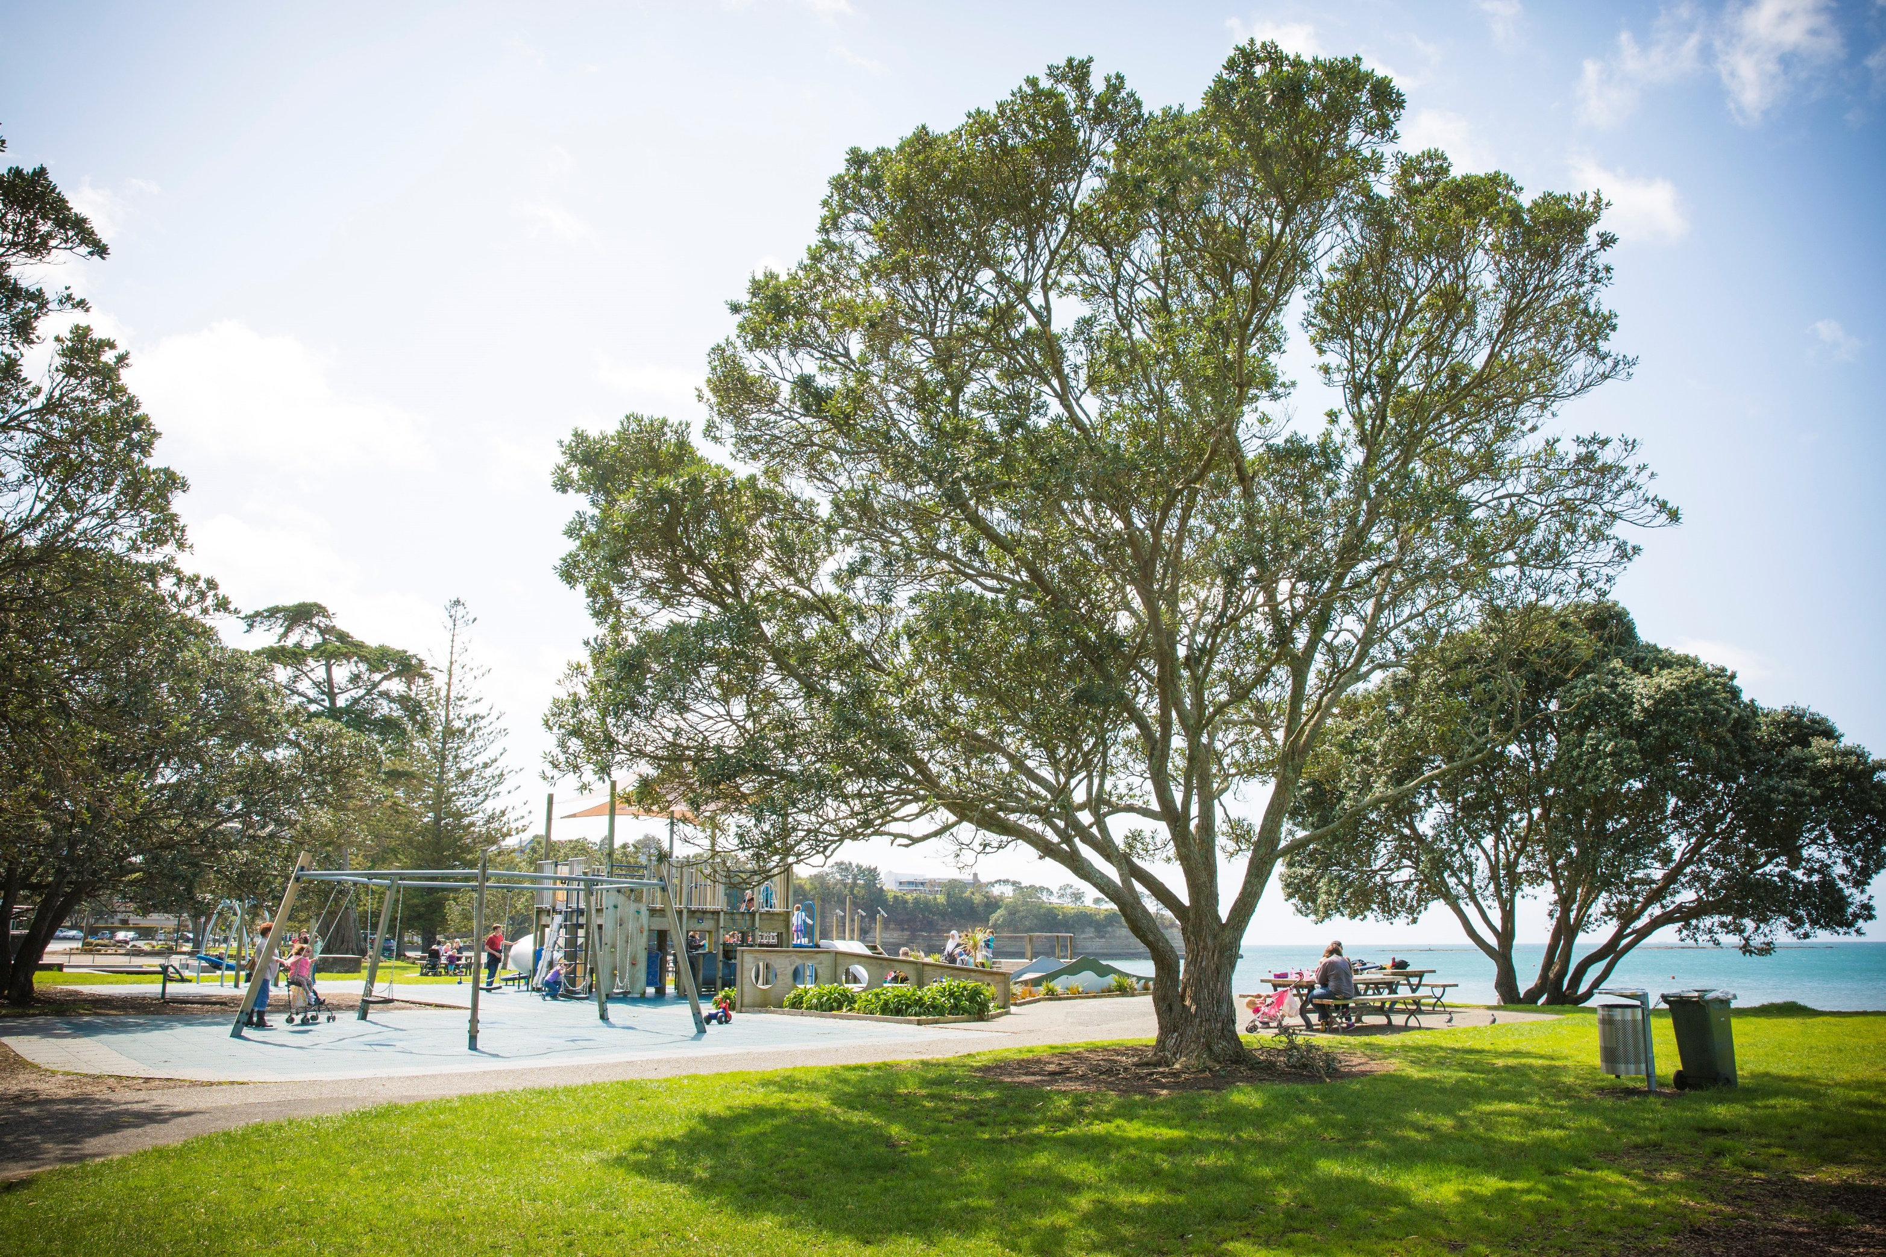

Draft
community consultation

Hibiscus & Bays

Local Parks Management Plan
  - Have your say until 27 May 2020
We want your feedback on the draft Hibiscus and Bays Local Parks Management Plan.
The draft plan covers 287 parks and reserves with over 600 hectares of open space in the local board area.
Visit your local library, service centre or aucklandcouncil.govt.nz/haveyoursay for more information, to view copies of the plan and give your feedback.
Find out more: visit aucklandcouncil.govt.nz or call 09 3010101 |  | 