Kootuitui ki Papakura
Workshop Thursday 17 October 2024
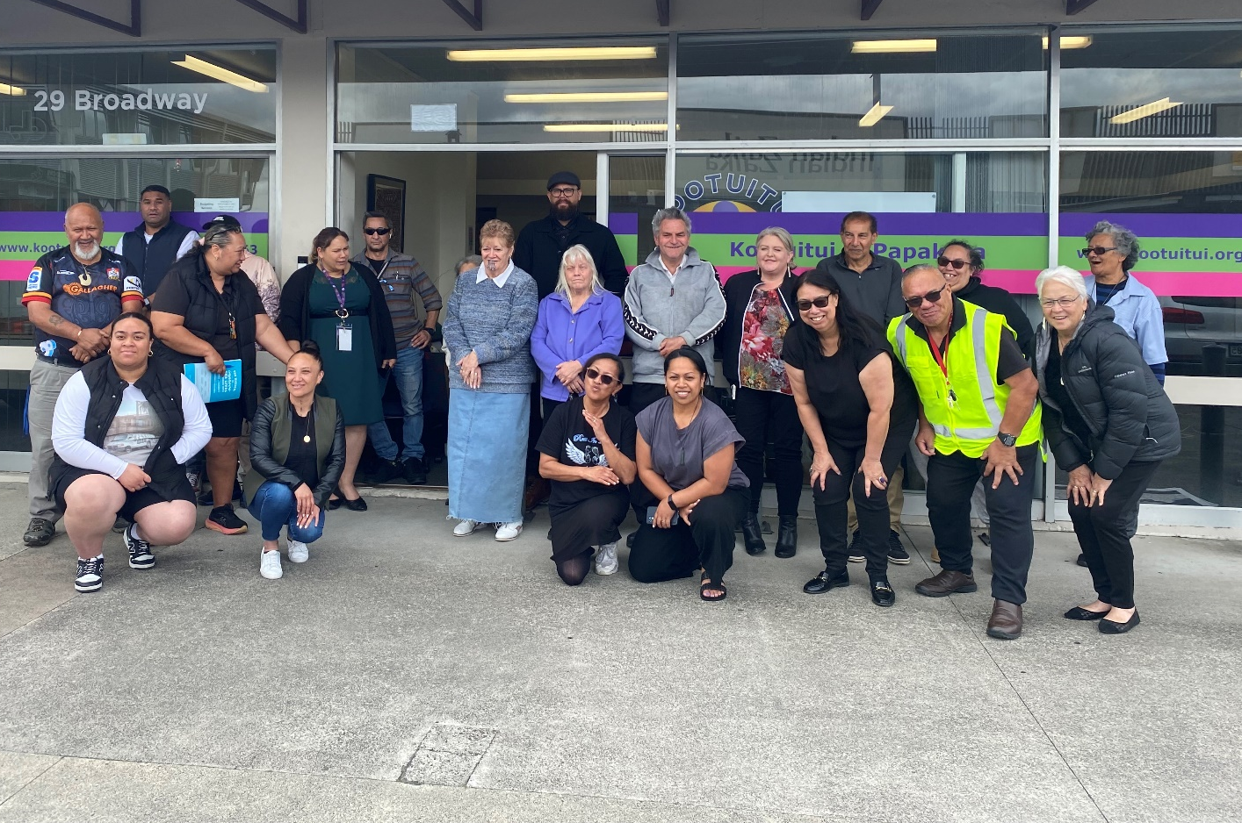
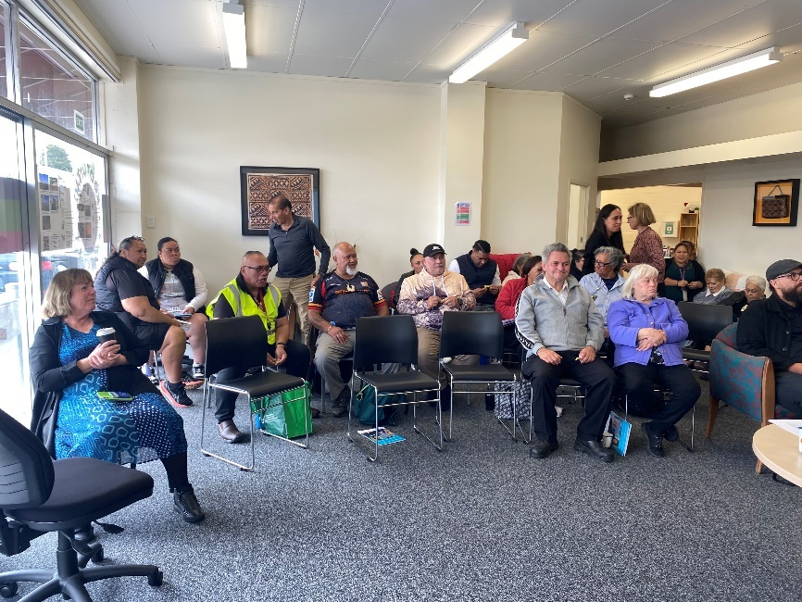
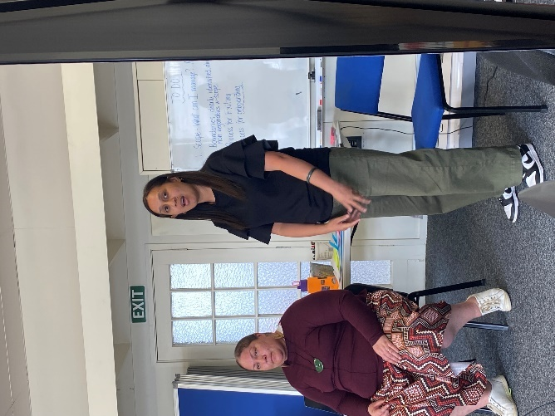

What you talked about

Building stadiums isn’t real life, out here is real life.
There is a financial crisis now and that is devastating for people already.
All those contacts you have across the world or in Honolulu can’t help you in an emergency. So, get off your boxes and digital devices and get to know your community.
We have noticed more rainfall, more lizards and earlier frosts.
Our basement has started flooding more frequently due to more construction.
Kowhai blooming in June when the don’t normally bloom until November.
Spring flowers blooming in winter!
We are local and we know the people, have the networks and where the resources are,
When there were floods in Drury houses were flooded, and people need somewhere to go. They want to someone they knew. Then they realised they needed more support. They had nothing when they got back to their houses and businesses. They had nothing and needed to clean up.
For the last 2 years the PD boys have been planting around the coastal areas.
We need to develop our own plan. I remember how my mother used to work out how much was needed for the family in an emergency and would buy one thing each pay until we had a great emergency kit.
As a young man we used to make rafts and go fishing in the mangroves in Pahurehure. In storms we went out because the fish used to go into the mangroves for protection. We used to get mullet and flounder. I wouldn’t do it now!
The post it notes

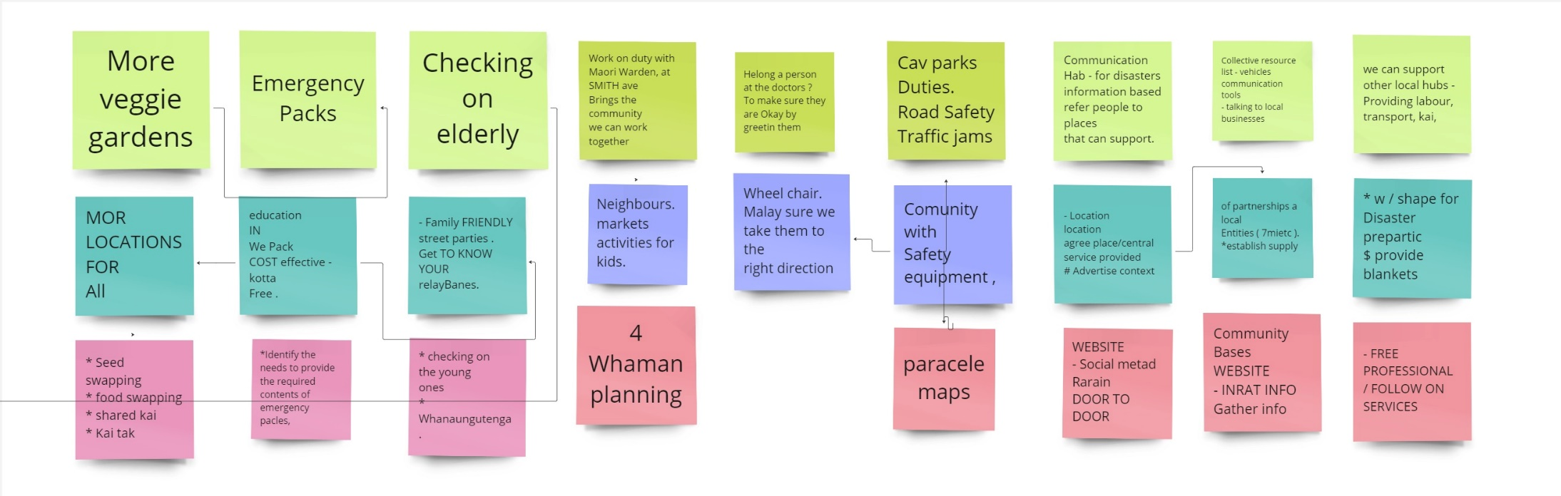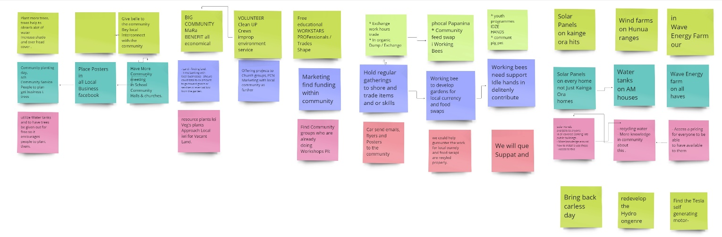

Ideas for things we could do

What can we do? | Idea for how | Idea for how
Work on duty with Maori Ward at Smiths Ave.  Bring the community together  We can work together | Neighbours  Markets  Activities for kids | Whānau planning ng
Helping a persona at the doctors  To make sure they are ok by greeting them | Wheelchair making sure we take them to the right direction | Google maps
Car Parks  Duties  Road Safe  Traffic Jams | Community with safety equipment
Communication Hub for disasters information based refer people to places that can support | Building - location, location, location  Grad place/central  services provide | Website  social media  radio  door to door
Collective resource list - Vehicles, Communication Tools  talking to local businesses | partnerships with local entities (iwi etc)  Establish supply | Community based website  input info  Gather info
We can support other local hubs providing labour, transport, kai | Workshops for disaster preparation  provide blankets, food, etc | Free professional follow-on services
Plant more trees to help absorb a lot of the water  Increase shade and overhead cover | Community planting days  Community Service  People to plant  Get business to donate trees
Raise awareness  Hold regular wananga to share relevant discussion  Murals | Place posters in all local business and Facebook
Give back to the community  Bey local  Interconnect with the communities | Have ore community meetings in schools Community Halls and Churches.
More vegetable gardens | More locations  easily accessible for all | Seed swapping  food swapping  shared kai  Kai tahi
Emergency Packs | Education  match what is in the pack  Cost effective > kotta?/Free | Identify the needs to provide the required contents of emergency places
Checking on the elderly | Family friendly street parties  Get to know your neighbours | Checking the young ones  Whanaungatanga
Exchange work hours  Barter and Trade  Inorganic Dump/Exchange | Hold regular gatherings to share and trade items and or skills | Can send emails flyers and posters to the community
Local Papakura Community  Community Food Swaps  Working Beds | Working bee to develop gardens for local currency and food scraps | We could help guarantee work for local currently and food scrap and recycled properly
Youth programmes  Idle Hand and community pig pens | Working bees need support I idle hand can definitely contribute | We will give support and advertise to the community.
Big Community  Mara  Benefit all economically | Resource Plans i.e. vegetable plants  Approach Local Iwi for vacant land  Seed library  Nursery | Land finding land  Time banking with local businesses - 3 hours could total to X a month to go toward goods or services or even kai box from the garden
Volunteer clean-up crews  - improve environment  -service | Offering projects to church groups PCN  - Marketing with local community and further | Seed swapping  food swapping  shared kai  Kai tahi
Free educational workshops  - professional/trades/shops | Marketing  find funding within the community | Find community groups who are already doing workshops
Solar Panels on Kainga Ora homes | Solar Panels on every home not just KO homes | Solar panels available to anyone on covered parking lots and public buildings  More knowledge around how to install and use these  Access to these
Wind Farms on Hunua Ranges | Water tanks on all houses | recycling water  more knowledge in community about this
Wave energy Farm in our inlet | Wave energy farm on all houses | Access and pricing for everyone to be able to have available to them
Bring back carless day
Redevelop the Hydro engine

