Accessing Development Contribution funding area maps
1. | - Enter the search terms Auckland Council GeoMaps into your search engine  Alternatively, click on this link to access GeoMaps  - The terms and conditions box will appear. You will need to accept the terms and conditions to access the maps.
2 | - Click on the Themes icon  - Select Regulatory  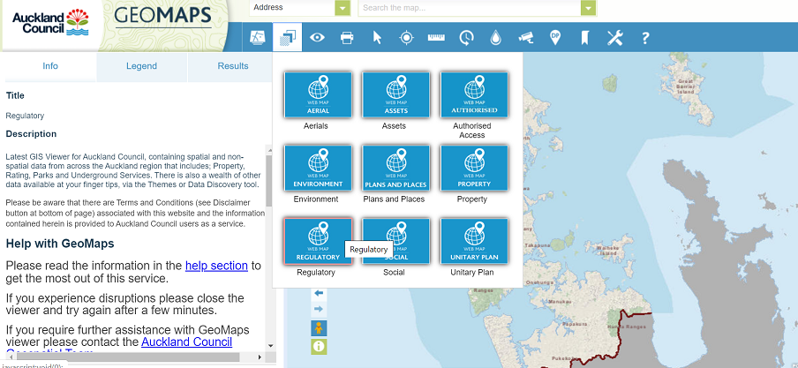
3 | - Click on the downward arrow to the left of Development Contributions to display options  - Click in the box to select your option  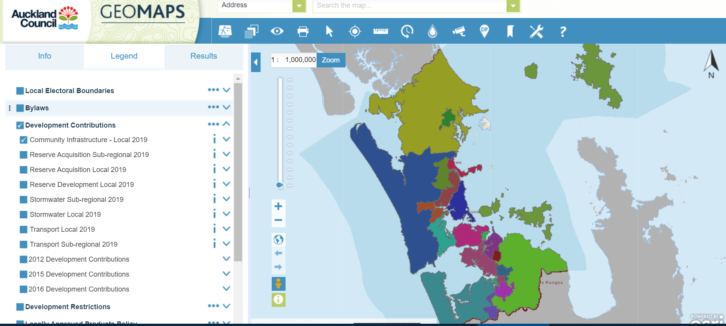
4 | - Click on the downward arrow to the right of the maps for the policy you require to display the key to the areas.  