Red Hill Community Centre
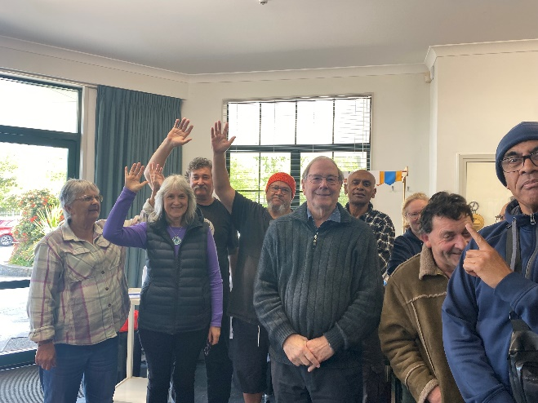
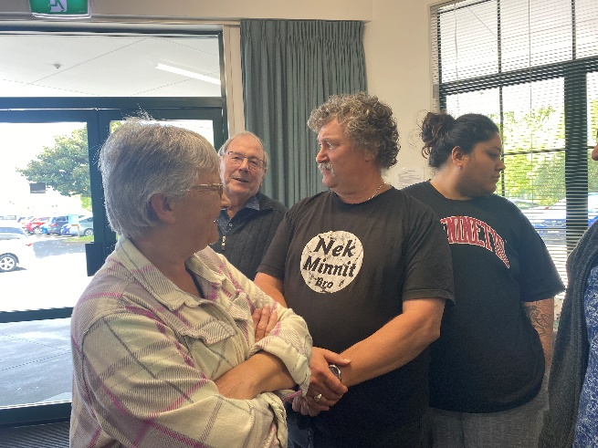
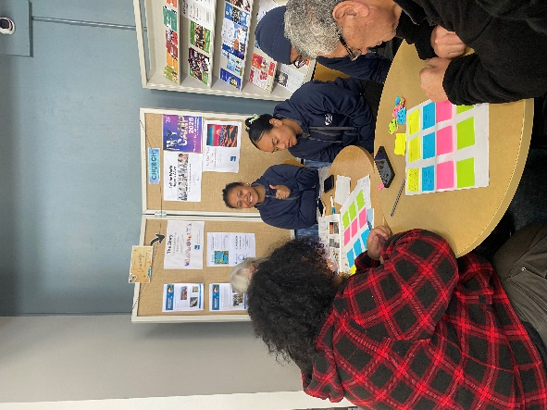
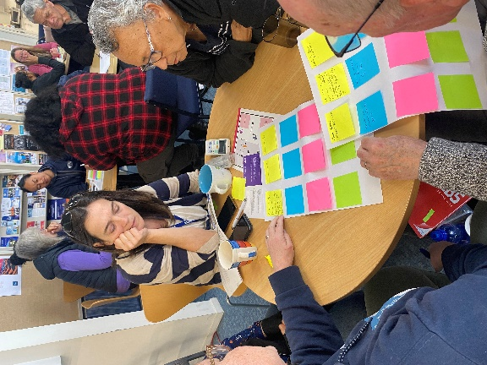
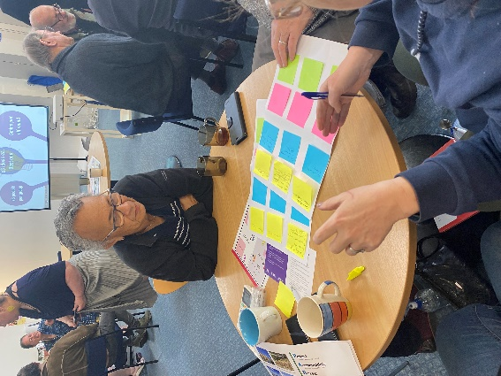
Workshop Saturday 21 September 2024

What you talked about
Climate resilience - We are all in it together.

We have got to feed our children.
Places owned by the community.

The ponds on our property have overflowed 2m higher than is has in over 20 years.

The stormwater pipes filling up more now than they used to.

Ideas for things we could do

What can we do? | Idea for how | Idea for how
More community gardens.  Teaching people to grow food + cook it.  Wetland replanting | Notify Council when needing cleaning | Community ownership of gardens not Council  Should be funded by Council or other sponsors
Slug lines | Talk to Rashan at Red Hill community centre who has seen them work.
Street Level  time banking  - More green roofs  - More fruit tees + native planting. | Education on how time banking [works] | Creating a network of people willing &@ able to time bank.
Networking Together  Improve the Infrastructure  Change the structure of set up of storm  water | Talk to Local board about  priorities and  how we can  help
Communal! Eating | Support Marae.  - Bread table [RCC]  - Tuesday DINNER (ANGLICAN)  - Local community  events. | Communal EATING  - PLANNED STRATEGY for the area (calendar)
Neighbourhood  watch | Encourage  Community  networking. | Gathering people with specialised  skills to inform.
Guerilla Planting | NIGHT TIME PLANT IT  on  HI-VIS, CANYAMS  Sauce comes OUT | identify spaces.  Seed bombs.
Small water  tanks on each  dwelling | FUNDING  (source the funding)  FUNDRAISER  - Recycling Plastic to make cheaper tanks | Grey water  systems
Street pantries  + community  Pantries | (Alternative Neighbourhoods) Focus to source pantries | Build them.  Pataka Kai
Events for fundraising | (Alternative Neighbourhoods) Focus to source pantries | Build them.  Pataka Kai
PLANT  TREES | Guerilla planting, | plant natives  seed bombs.  fruit trees on berms
EDUCATION  WORKSHOPS  FOR YOUNG  PEOPLE | Encompass more age groups  'intergenerational' | Find a venue  - Libraries  Find local tutors  Youth Council  Ask young people  what they want
Regular street sweeping  - More community  meet ups to get  to know people | Bring back neighbourhood watch. | Community /Street  Right of way  Parties.
More street  clean ups | Streams regularly  cleaned | identify streams  and volunteers.  ( Youth
Major solar [energy] Plants
servicing the Papakura
grid.
Plant Fruit Trees: Plum, nectarines, apple, oranges, avocado, figs, lemons, feijoas
Transport Access, Easy, Affordable
First aid kits
for every car
+ dwelling
Community  database of  skills | Design a page  Contact list  Resident groups  Stay local  BUY LOCAL
Training  workshops | " Brain storm what people  want  - Use council resources  (topics )  - Organise  - Advertising  - Venues  - Free ! | community resources
Emergency  Preparedness | Street Meets  equipment. | Street Meets  equipment.
Repair shop | Training  Venues | Tools & Experience
Sustainable Products  in RCC | table  - newsletter  think long-term. | Reduce  Reuse  Recycle  Rethink
Comm GARDEN  STREET NETWORK | Network  with  existing  Garden  group | Source plants,  check plants,  volunteers,  roster for caring
EDUCATION for the committee  For emergencies  Having a place or youth to go | Training  workshops  held at RCC | Accessible practical info  - monthly reports  or updates regarding  emergency prep on flyers.  - social media presence.  - connections/ relatable.  network with community workers e.g. B light
Back to basic  workshops | Gather a database of skilled personnel | offer courses / free  wānanga demons.  passing on knowledge  Time Banking.

