Takaanini Gurdwara
Workshop Saturday 21 September 2024
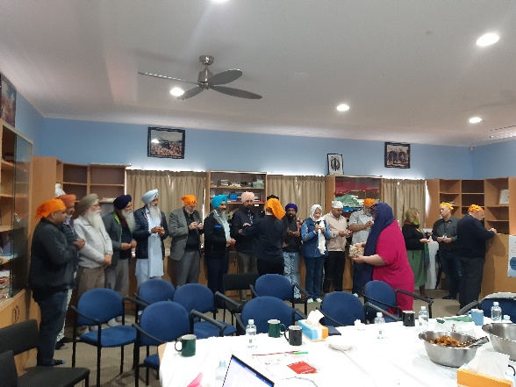
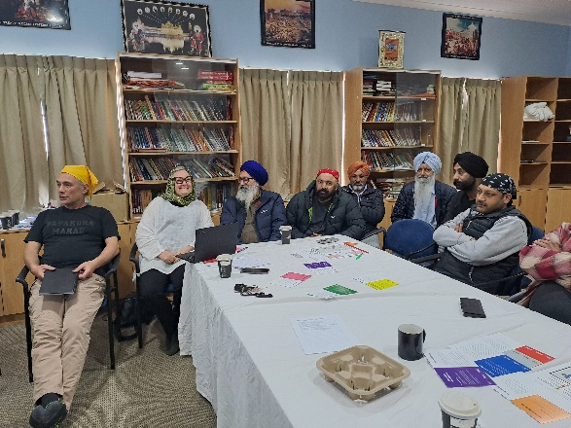

Less Frost compared to 20 years ago | Less Rural land | Less birdlife and change of species | Traffic increase
More mangroves - grew from motorway time | Less tress | Increase in Indian community | More cars per family
 | More storms | More shopping therefore more throw-away pollution | More building

Changes we are noticing

Ideas for things we could do
- Address social and economic inequity
- Need better public transport especially in the weekend, can we advocate for his
- Neighbours/Streets/Families looking out for each other
- Can we have help to grow our own food at home because the supermarkets are so expensive
- Solution growers for a co-op/organisation where people can by food directly
- People don't have space to grow their own food
Teach people how to grow vertical gardens or gardens for small spaces
- Food forest and community
- Encourage people with a little land to grow tress
- Have a disaster resilience plan and practice (Papakura has a plan).

What we talked about

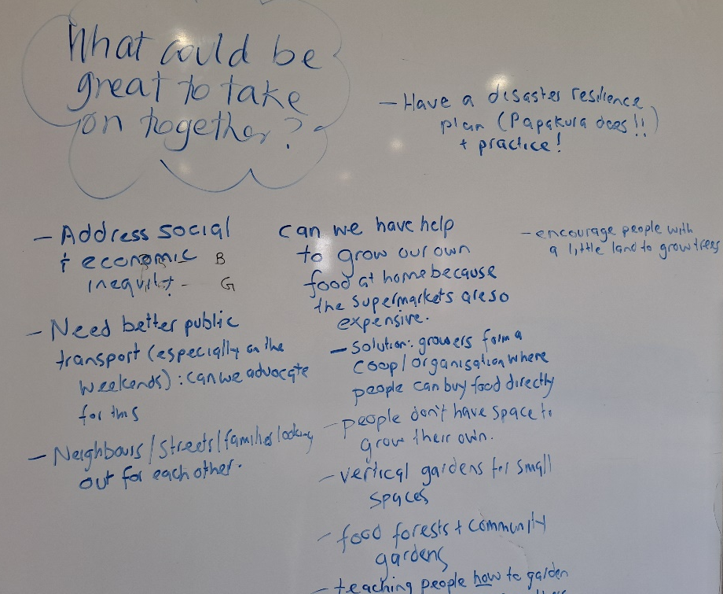
We open the hub almost 7 days a week.
Our kitchens must be open almost every Gurdwara and open to everyone.
We can easily get 5000 people into the Gurdwara in an emergency.
We message using WhatsApp to a group of 800 people.
During the cyclone and covid we experienced generosity from the local and national community, from growers all over Bay of Plenty and Pukekohe communities who provided fruit and vegetables the day after the Covid lockdown to start. They were very fast to help people and very organised during Covid lockdown.
When I phone any of the agencies helping communities for food, they always refer to Gurdwara Awhi App and messages comes to Gurdwara to help two drivers go every evening.
Our community are connected using WhatsApp. We have 800 members of the community connected this way.

